 TMB Orbital Floor and Carpet Encapsulation Machine

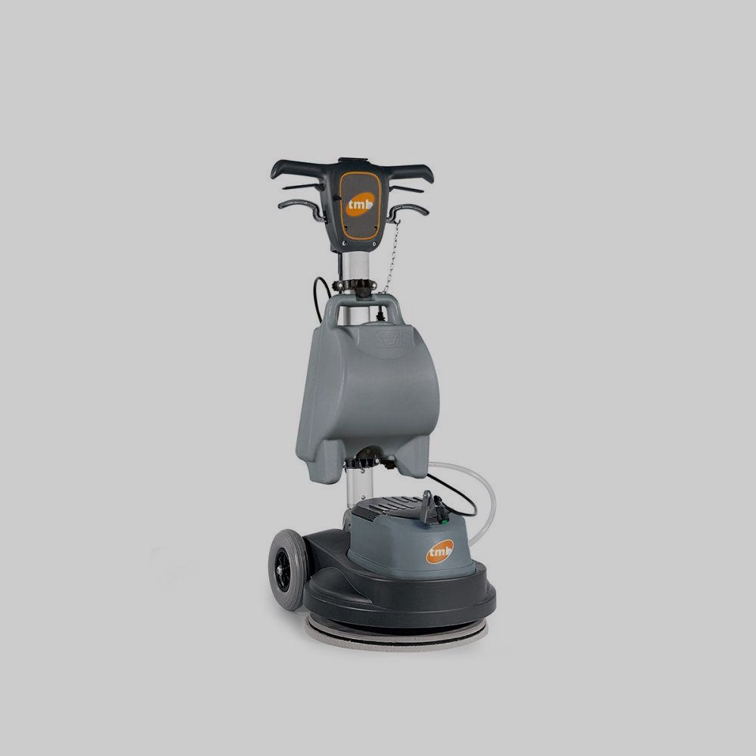

**TPO LINE 43** - Recommended for the maintenance of floors - They offer as standard tank, US cable and pad holder. The rotary-orbital movement of the TPO single disc machines ensures exceptional results on any type of floor. They are suitable for the most frequent applications, such as background cleaning and stripping. They also guarantee surprising results when cleaning carpeting by encapsulation method. Numerous accessories are available for every type of intervention.  
  
**TFO LINE** - Recommended for maintenance, basic cleaning, treatments and extraordinary maintenance operations. One or two speed models with the possibility of dry polishing and crystallization. Suction kit available for sanding parquet.  
  
**TOR LINE**- Recommended for thorough cleaning, treatments and extraordinary maintenance operations. One or two speed models. Suction kit available for sanding parquet. An important feature is the quick release of the engine crankcase from the trolley and the weight of 37 lbs and the disconnection of the electrical system to facilitate transport.  
  
**Why choose a single brush with a roto-orbital system?**  
- Two movements in one: rotational-orbital: at the same time as the natural rotational movement of the disc, which can vary from 0 to 90 rpm, the system always generates a constant orbit that allows passing very often on the same point, very quickly. On surfaces such as hard floors, resilient floors, wood, resins, carpet, it creates rotational movements with a diameter of about 0.5 inch, with 1400 steps per minute. This guarantees an extraordinary, rapid performance when washing, polishing and crystallizing.  
- Perfect adhesion to the surface: the work area is always constant and the brush / disk always remains level with the surface adhering perfectly.  
- Forward and backward movement and easy tilting: the action of the brush is effective during any movement: back and forth or tilt, always remaining level on the surface.  
- Less use of water and detergent: the orbital movement keeps the used water inside the disc that is not sprayed outside. Thanks to this technology the consumption of water and consequently of the detergent is drastically reduced.  
- Low energy absorption: maximum absorption of 2.5-3 Ah.  
- A single machine for multiple functions: the rotary-orbital system guarantees all interventions on various types of floors thanks to its versatility and the availability of specific accessories that make the machine versatile.